MILITARY SERVICE RIFLE SHOOT
CESSNOCK RIFLE RANGE
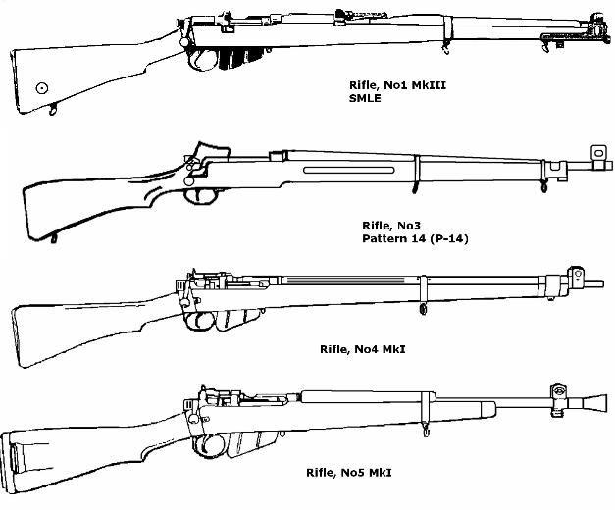
INFORMATION
Entry fee $20.00
A BBQ sausage sizzle lunch is provided
Medals awarded for the first 3 places in each class.
Shoot is two 10 shot stages (2 optional sighters per stage). Ranges are 300 and/or 500 yards. Check the CRC Inc website for more information.
Shoot commences at 9 am with competitor marking using 303 era dimensioned manual targets.
COMPETITION RULES
1/. The competition is conducted under Standard Shooting Rules (SSR’s) for Australian Rifle Clubs (ie National Rifle Association of Australia).
2/. An empty chamber indicator must be inserted into the rifle chamber as per the SSR’s.
3/. Firearms licence must be presented when entering.
4/. Rifle must be an ex service rifle in the original military calibre.
5/. Two classes are available for competition:
Target Rifle Class – Blade foresight with sling support in the prone position. Rifle must have military profile barrel. Aperture sights (eg Central etc) allowed.
Field Class – Telescopic sight with rest/bipod support in the prone position or shooting table. Barrels must be military profile.
CONTACT
Please text Gavin on 0400721067 if you are intending to participate.
DATE OF NEXT SHOOT: SUNDAY 23 AUGUST 2020

