Dear Colleagues

**Starting a new shooter on the correct techniques, scoring a possible in 13 months**

***The Problem*:**new shooters are often started by coaches using inadequate techniques, which many mid-level shooters may be found using years later.

Many coaches, who introduce new F Class and Target Rifle shooters, have very different ideas on the techniques which a new shooter should be first taught. Sadly, it appears that there is no general agreement on these techniques.

This article describes a young shooter’s experience which led him to score his first *highest possible score* (HPS at Bisley), 13 months after starting to learn to shoot (TR).

***Discussion*:** as a consequence of the different ideas held by coaches, most of the following techniques are rarely taught, for a new shooter to have an advantage in TR or F Class.

The most common difficulties observed among new and experienced shooters are:

* the ability to release a shot with the muzzle dead-still at the moment of trigger-release (TR, F Class) [supporting the rifle dead still (TR) enables a TR group to be 1 MOA instead of 2 MOA]
* changes in the position of the shooter’s body and loading hand during a shoot, resulting in change of the natural point of aim (TR, F Class) [causing a group to split into two groups]
* varying tension of the loading hand at the pistol grip (TR, F Class) [enables a group to remain unchanged, instead of being split into sub-groups on each side of the bullseye]
* allowing the forward hand near the sling swivel or hand-stop (TR) or the rear hand at the pistol grip (TR, F Class) to absorb some of the recoil of the rifle [enables a group to avoid being distorted to high-left and low-right for a RH shooter]
* non-centering the group into the middle of the V-bull (TR) or X-ring (F Class) [enables a group to avoid being split and/or located on one side of the V-bull or X-ring]
* releasing shots when the flags have returned to the same wind velocity and angle [enables wide shots to be avoided on each side of the group].

A new shooter who releases shots from a rifle supported on a rest, is ideally suited to learn the trigger-release technique from the outset. The shooter needs to become proficient in this technique for both TR or F Class. It results in the natural reduction (within about 4 seconds) in the concentration of adrenaline in the bloodstream. If this does not happen then tremors may move the muzzle at the moment of departure of a projectile. These tremors result in a 2 MOA group.

***Practical*:** the learner-shooter began when just old enough to legally shoot at a rifle range. After 12 months, his coach had started to teach him to simultaneously undertake:

* *positioning of the loading hand at the pistol grip* for every shot, *via* fingers that anchor the hand evenly, *via* the three large muscles of the palm, *via* loose positioning of the thumb and *via* the index finger which releases the trigger at the first joint
* *uniform tension of the hand against the pistol grip* [for a RH shooter, greater tension sends shots to the 6-ring, bullseye or inner on the right; but if tension is less, shots go left]
* awareness of *light refraction* (invisible bending of light rays down the range), which leads to changes in target height, sending shots to a high bullseye or inner; alternatively, shots may go underneath or above
* avoidance of *tension due to the cheek against the butt* (more tension for a RH shooter will send shots toward the left, as far out as the bullseye or inner line)
* *follow-through* (occupying the mind for the full period of trigger release, e.g. by observing and estimating changes in wind velocity from the flags).

These techniques, which need to be performed at the same time, cannot be suddenly mastered at the start of a shooter’s career. Most people are unused to performing tasks at the same time. His coach considered he should start by resting the rifle and commence the technique for centralising the group. Hence, the young shooter used a rifle rest for the first 11 months, then began learning to use the sling. After 2 months he produced the following group at 600m.

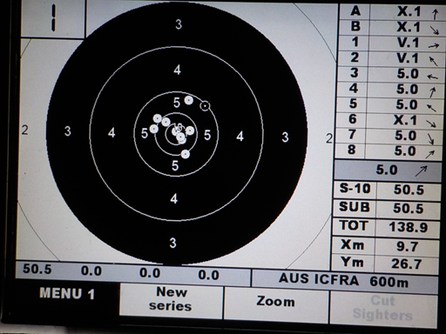

***Summary*:**  from the outset, supporting the rifle on a rest, the shooter commenced the release of shots with a 4 second delay. In this, he aimed the dead-still rifle right through to the point of release. His skills with the other simultaneous techniques were still incomplete. However, it can be seen from his group, that he had succeeded in placing about 80 percent of shots into the 1 MOA V-bull group, i.e. released to avoid tremor movements at the muzzle.

As the shooter continues to master the techniques, there will be a noticeable increase in his self-esteem, which will be seen from his quiet thinking when taking a position on the firing point. It is expected that he will soon find he can score 10 Vs. When this happens, experienced shooters will notice a change in both his self-esteem and composure, which will become part of his overall shooting performance.

Best regards

Geoff